Bikes on Sidewalks
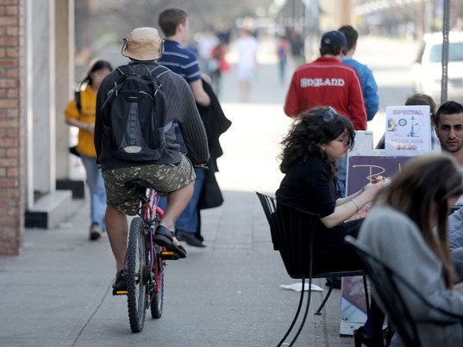
Bicycling on the sidewalk isn’t safe, it’s slower…and it can lead to an accident. Riding should be done in the street or on designated bicycle or multi-use paths. Here’s why:
- Riding in the street is safer than riding on the sidewalk. Studies have shown that the risk of accident is 1.8 times greater for riders on sidewalks than riders in the street. If you are riding on the sidewalk against traffic, the risk can be up to 5.3 times greater.
- Riding on the sidewalk creates a hazard for pedestrians. They aren’t expecting you on the sidewalk and can be startled. Pedestrians often move haphazardly on the sidewalk, and you as the cyclist often do not have enough time to react to avoid crashing into them. Pedestrian/cyclist crashes can cause serious injuries to both pedestrians and cyclists. If you crash into someone, you could be legally liable.
- Sidewalks also present additional obstacles such as storefront doorways, street furniture and poles that are hazards to riders.
- It is more difficult for drivers to see you when you are on the sidewalk. Parked cars on-street obstruct the driver’s view of you on the sidewalk. Also, buildings at intersections often block the site angles of you for both drivers and pedestrians. This increases the risk of collisions at intersections and driveways.
- Bicyclists have a legal right to ride in the street.
  - If there is not enough room to a bike and car to share the lane, you can legally “take the lane” and ride in the middle of the lane.
  - Biking in the street is faster. You get to where you are going sooner. Sidewalks are often congested, have obstacles to negotiate around and cyclists have to be more on alert as both cars and pedestrians do not expect you to be on the sidewalk.
  - Busy streets in town can often be avoided by using a parallel side street with a lower traffic volume that allows you to avoid congestion and have an enjoyable ride.
  - There are many designated bike routes through the City and on County roads. Look for the sharrows painted on the street, or for signs saying, “Bike Route”.
  - Riding bikes is expressly prohibited on the sidewalks in the downtown area – from Third Avenue to Eighth Avenue, between Elm Street and Irving Street. Bikes may be walked on these sidewalks.

